

**DATABASE MANAGEMENT SYSTEM**

**(**CS310**)**

# TOPIC : CAR INSURANCE DATABASE

**Under The Guidance of : UMA S**

**Done By : Group 12**

**Group Members :**

DARSHAN (18BCS023)

JAGAEESH(18BCS033)

GIREESH(15BCS035)

ARUN(18BCS013)

BHARATH CHANDRA(18BCS077)

## INTRODUCTION

A database management system (DBMS) refers to the technology for creating and managing databases. Basically DBMS is a software tool to organize (create, retrieve, update and manage) data in a database.

**AIM**

It is implemented using MySQL respectively. The project consists of twenty one tables mainly. Each table will have its own services. The main aim of a DBMS is to supply a way to store up and retrieve database information that is both convenient and efficient. By data, we mean known facts that can be recorded and that have embedded meaning. Normally people use software such as Microsoft ACCESS, or

EXCEL to store data in the form of database.

**The vehicle insurance system can include:**

* Providing people insurance facilities during emergency situations.
* Identification of accident incidents.
* Storing personal information of customers in more secured manner.
* Planning detailed checklist.

**User Interface**

We are familiar with the syntax of MySQL, hence we have used MySQL syntax and queries for interface between users and server.

**ANALYSIS & REQUIREMENT SPECIFICATION Purpose:**

The purpose of this project is to outline vehicle insurance data and requirements, to recommend data management solutions and to provide information regarding the vehicle insurance. The purpose of this project is to develop a data management system to consolidate, organize, document, store and distribute information related to vehicle insurance management system.

A centralized database created to consolidate data, allowing integrated, long term analyses, and dynamic search ability with user friendly query tools to be performed to support adaptive management. Many data collection, analysis and presentation software programs that are currently being used must be able to interface with any new data management system. Continuity with consistent data collection methodology is enforced by a common database system, allowing for standardized format for forms ad reports between projects.

**Scope:**

The scope of the project is managing a consistency and storage of data by dedicated data administrator. It provides most of the features that a Database Management System should have. It is developed by using MySQL database. It has been implemented in WINDOWS platform.

**FUNCTIONAL REQUIREMENTS:**

**Three Modules are used in this project namely Admin & User:**

* Admin: can insert, analyse the tables.
* User: can register their information.

**Non-Functional Requirements:**

**Software Specification:**

MySQL Libraries

MySQL Workbench 8.0 CE

Operating system : Windows10

## ABOUT THE PROJECT

This project has been developed using MySQL software which is queries oriented. Changes at the queries and the way in which it uses a system state may cause anticipated changes in the behavior of other result.

ER DIAGRAM

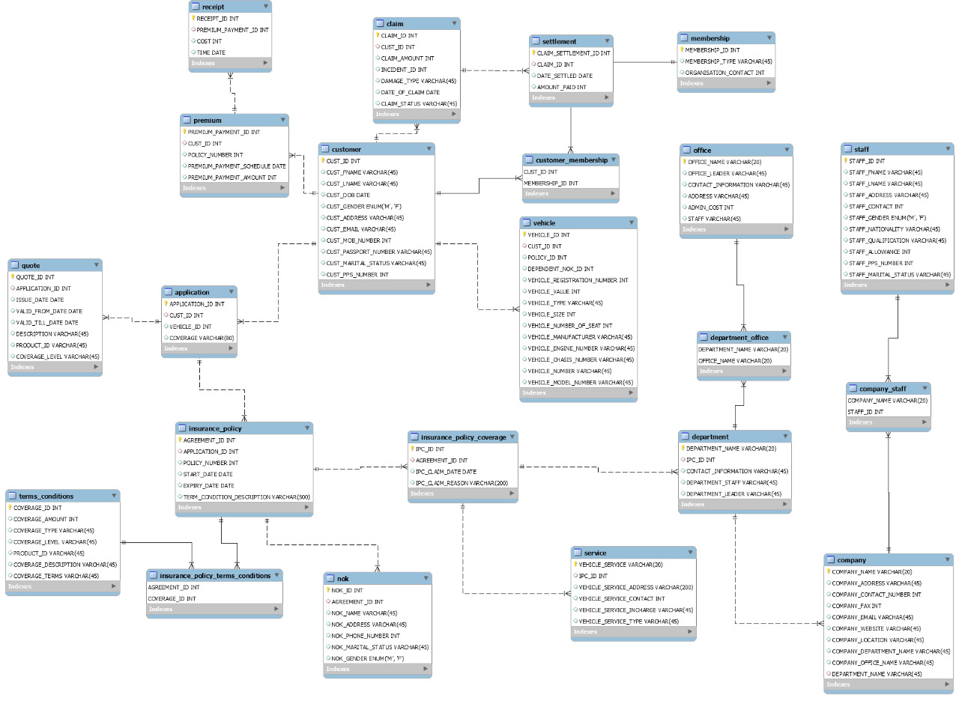

### CONCLUSION

In this project we have tried to create a database which is easy stores user information, and easy to access and user friendly. The database keeps a backup of the vehicle insurance management data which includes their details and we have tried to implement some of the useful queries on our database.

8

### FUTURE ENHANCEMENT

In this, database stores and keeps a backup of the vehicle insurance management data which includes their details. Here we assists with the design, planning and management of a clients vehicle insurance. Further if given chance & time we would like to modify the application by adding external features like Vehicle services, and additional features.

**-------------------------------THANK YOU-------------------------------**